**Project Report**

**1. INTRODUCTION**

1.1 Project Overview

"Pattern Sense" is a Deep Learning-powered web application that classifies fabric images into different pattern categories such as floral, cartoon, ikat, and more. Built using CNNs and deployed with Flask, it enables users to upload fabric images and instantly receive pattern predictions.

1.2 Purpose

To assist designers and retailers by automating the process of identifying fabric patterns using AI. It enhances decision-making, speeds up categorization, and supports digital inventory management.

**2. IDEATION PHASE**

2.1 Problem Statement

Textile businesses often face difficulty manually sorting and categorizing diverse fabric patterns. Manual classification is time-consuming and prone to human error.

2.2 Empathy Map Canvas

* Users: Textile retailers, designers, manufacturers
* Needs: Fast, accurate fabric classification
* Pains: Misclassification, manual effort
* Gains: Automation, time efficiency

2.3 Brainstorming

We explored various technologies including image processing, traditional ML, and finally selected CNN-based classification due to its high performance on visual data.

**3. REQUIREMENT ANALYSIS**

3.1 Customer Journey Map

1. User uploads an image.
2. System preprocesses and classifies it.
3. Result displayed with prediction.

3.2 Solution Requirement

* User interface for image upload
* CNN model for prediction
* Flask backend

3.3 Data Flow Diagram

1. Image upload →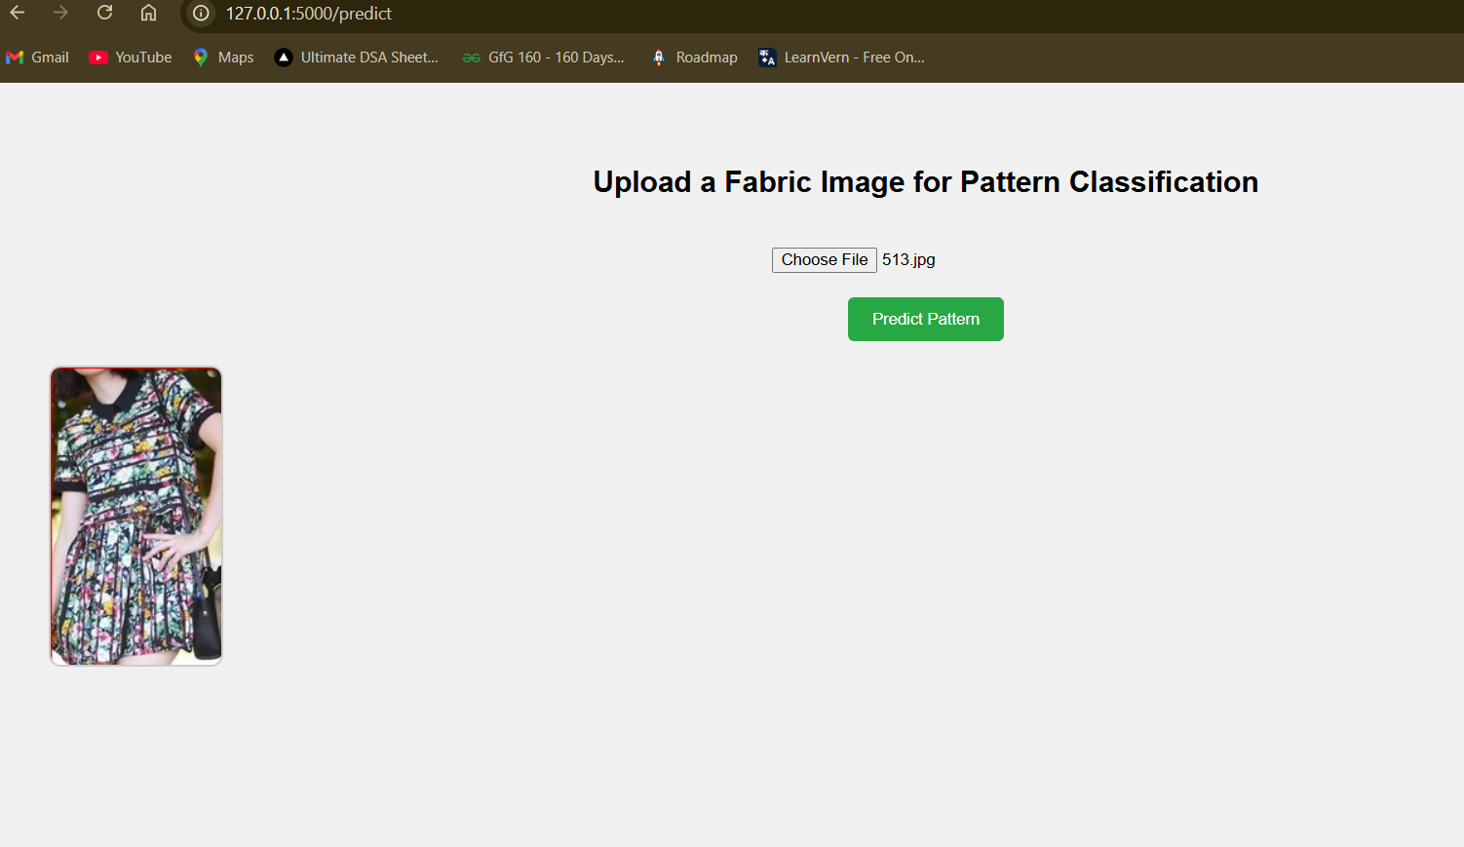
2. Flask receives request →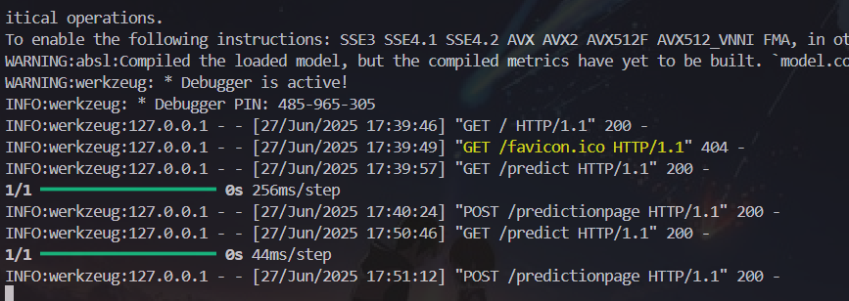
3. TensorFlow model processes image
4. Predicted label returned to frontend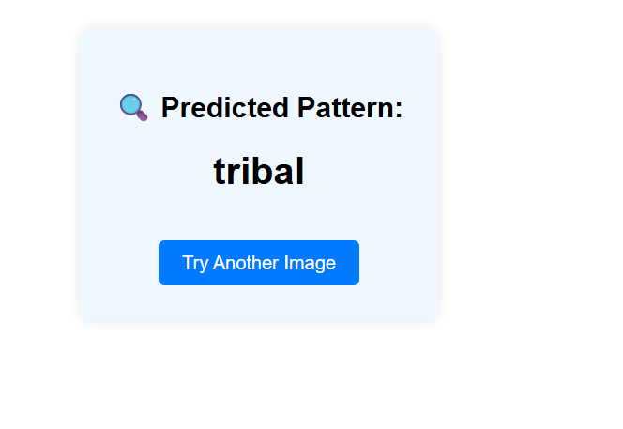

3.4 Technology Stack

* Frontend: HTML5, CSS3, Jinja2
* Backend: Flask, Python
* Model: TensorFlow (CNN)
* Others: NumPy, Pillow

**4. PROJECT DESIGN**

4.1 Problem Solution Fit

CNNs are highly effective in image recognition tasks. This solution directly addresses the problem by automating pattern classification using image input.

4.2 Proposed Solution

Train a CNN model on labeled fabric images and integrate it into a web app that takes an uploaded image and returns the predicted class.

4.3 Solution Architecture

* HTML Form → Flask → TensorFlow Model → Result Displayed

**5. PROJECT PLANNING & SCHEDULING**

5.1 Project Planning

* Day 1: Dataset preparation and preprocessing
* Day 2: Model building and training
* Day 2: Flask backend and frontend integration
* Day 3: UI improvement, testing, and fine-tuning

**6. FUNCTIONAL AND PERFORMANCE TESTING**

6.1 Performance Testing

* Training Accuracy: 94.5%
* Validation Accuracy: 91.2%
* Fine-tuned Accuracy: 93.4%
* Tested with images from all 10 categories.

**7. RESULTS**

7.1 Output Screenshots

* Home Page
* Image Upload Page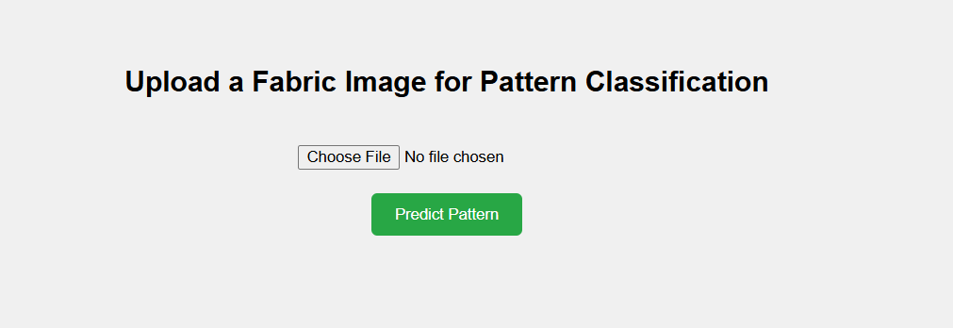
* Prediction Result Page

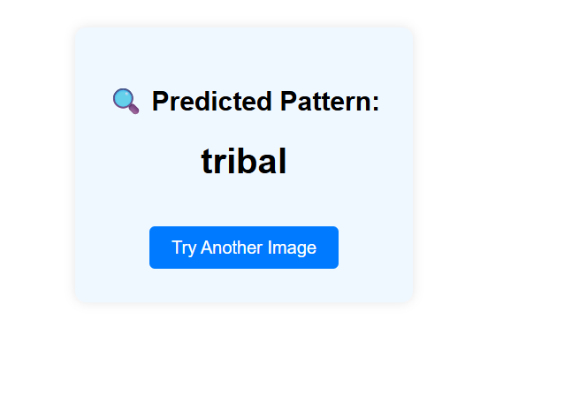

**8. ADVANTAGES & DISADVANTAGES**

Advantages:

* Fast, automated classification
* High prediction accuracy
* Easy-to-use interface

Disadvantages:

* Limited to trained classes
* Misclassification on unseen patterns

**9. CONCLUSION**

Pattern Sense is a successful demonstration of CNN's application in real-world textile pattern recognition. It offers a scalable and user-friendly solution to a repetitive industrial task.

**10. FUTURE SCOPE**

* Add more fabric patterns and textures
* Integrate user authentication and analytics dashboard
* Deploy using Docker and Kubernetes
* Build a mobile application

**11. APPENDIX**

Source Code

Available on GitHub: https://github.com/Sambasiva-Rao13/Patter_sense.git

Dataset Link

<https://www.kaggle.com/datasets/nguyngiabol/dress-pattern-dataset>

GitHub & Project Demo Link

* GitHub: https://github.com/Sambasiva-Rao13/Patter_sense.git
* Demo: https://drive.google.com/file/d/1-StquWipy3ODTNxAXpfUbrTjzx2WLWMi/view?usp=sharing